**Banking data analysis**

**Creating database bank in mysql**

CREATE DATABASE bank;

USE bank;

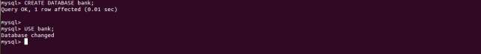

**Creating tables in mysql and inserting the data into mysql tables**

**Creating table loan_info**

CREATE TABLE loan_info (

loan_id int,

user_id int,

last_payment_date DATE,

payment_installation DOUBLE,

date_payable DATE

);

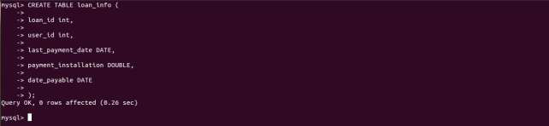

**Inserting data into loan_info table**

insert into loan_info values(1234,5678,'2017-02-20',509,'2017-03-20');

insert into loan_info values(1243,5687,'2016-02-18',9087,'2016-03-18');

insert into loan_info values(1324,5786,'2017-03-01',8976,'2017-04-01');

insert into loan_info values(4312,8976,'2017-01-18',9087,'2017-02-18');

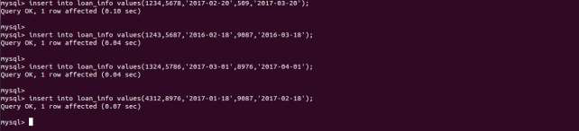

**Checking the data in loan_info table**

select * from loan_info

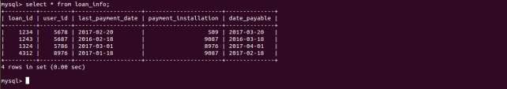

**Creating table credit_card_info**

CREATE TABLE credit_card_info

(

cc_number bigint,

user_id int,

maximum_credit DOUBLE,

outstanding_balance DOUBLE,

due_date DATE

);

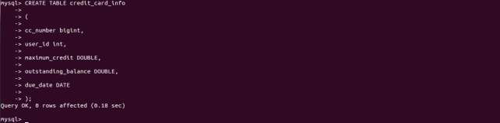

**Inserting data into the credit_card_info table**

insert into credit_card_info values(1234678753672899,1234,50000,35000,'2017-03-22');

insert into credit_card_info values(1234678753672900,1243,500000,500000,'2017-03-12');

insert into credit_card_info values(1234678753672902,1324,15000,12000,'2017-03-09');

insert into credit_card_info values(1234678753672908,4312,60000,60000,'2017-02-16');

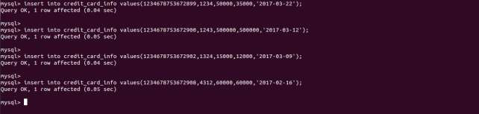

**Checking the data in credit_card_info table**

select * from credit_card_info;

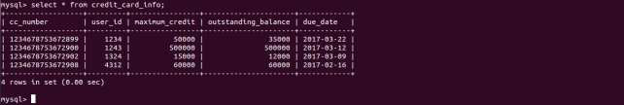

**Creating table shares_info**

CREATE TABLE shares_info

(

share_id varchar(10),

company_name varchar(20),

gmt_timestamp bigint,

share_price DOUBLE

);

**Inserting data into shares_info table**

insert into shares_info values('S102',"MyCorp",1488412702,100);

insert into shares_info values('S102',"MyCorp",1488411802,110);

insert into shares_info values('S102',"MyCorp",1488411902,90);

insert into shares_info values('S102',"MyCorp",1488412502,80);

insert into shares_info values('S102',"MyCorp",1488411502,120);

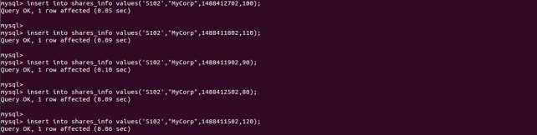

**Checking the data in shares_info table**

select * from shares_info;

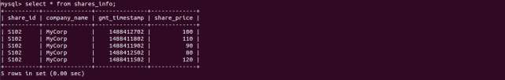

**Commit;**



**2.Exporting data from Mysql to HDFS using sqoop**

You can insert data in hdfs first and then move it into hive tables but I am using sqoop to directly insert my data in hive tables.

Since there needs to be three tables in hive. I have created shell script for multiple sqoop statements.

I have created script with name mysqoop.sh, so running script on my terminal.

./mysqoop.sh

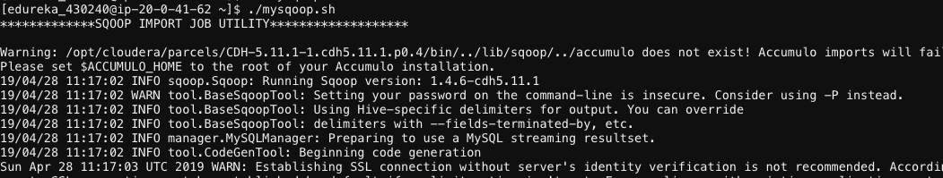

**Checking Output in Hive:**

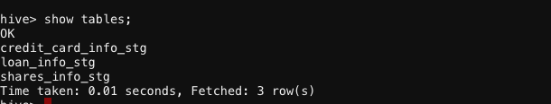

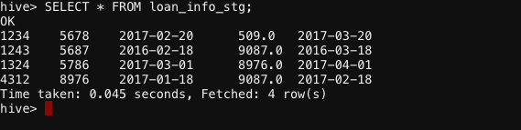

**3. Creating core tables and loading the data into the core tables from stg tables**

**Adding the udf into hive shell.**

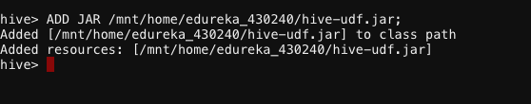

CREATE TEMPORARY FUNCTION encrypt AS 'encryption.AESencrypt';

CREATE TEMPORARY FUNCTION decrypt AS 'encryption.AESdecrypt';

**Creating loan_info table**

CREATE TABLE loan_info (

Loan_id string,

User_id string,

last_payment_date string,

payment_installation string,

Date_payable string

) STORED AS ORC;

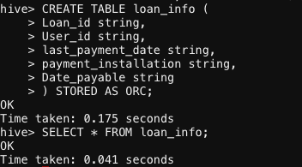

**Inserting data into loan_info table (encrypt data)**

INSERT INTO TABLE loan_info

SELECT encrypt(Loan_id),

encrypt(User_id),

encrypt(last_payment_date),

encrypt(payment_installation),

encrypt(Date_payable)

FROM loan_info_stg;

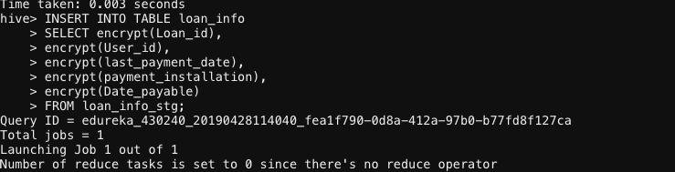

**Checking Data:**

SELECT * FROM loan_info;



**Creating shares_info table**

CREATE TABLE shares_info

(

Share_id string,

Company_name string,

Gmt_timestamp string,

Share_price string

) STORED AS ORC;

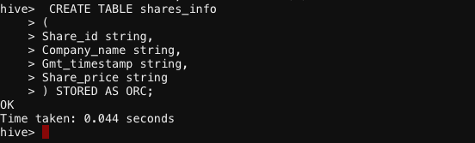

**Inserting data into shares_info table**

INSERT INTO TABLE shares_info

SELECT encrypt(Share_id),

encrypt(Company_name),

encrypt(Gmt_timestamp),

encrypt(Share_price)

FROM shares_info_stg;

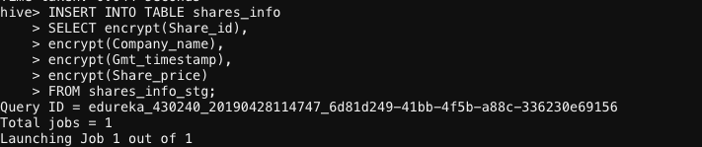

**Creating credit_card_info table**

CREATE TABLE credit_card_info

(

cc_number string,

user_id string,

maximum_credit string,

outstanding_balance string,

due_date string

) STORED AS ORC;

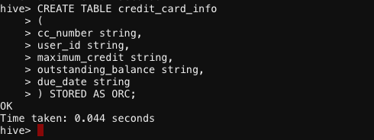

**Inserting data into credit_card_info table**

INSERT INTO TABLE credit_card_info

SELECT encrypt(cc_number),

encrypt(User_id),

encrypt(maximum_credit),

encrypt(outstanding_balance),

encrypt(due_date)

FROM credit_card_info_stg;

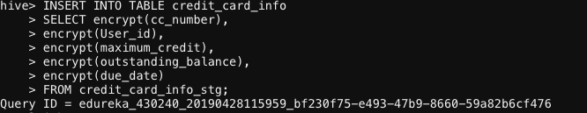

**4. Analysis**

**Decrypting the data for analysis:**

CREATE TEMPORARY FUNCTION encrypt AS 'encryption.AESencrypt';

CREATE TEMPORARY FUNCTION decrypt AS 'encryption.AESdecrypt';

CREATE TEMPORARY FUNCTION max_profit AS 'maxprofit.MaxProfit';

**6.1. Find out the list of users who have at least 2 loan instalments pending.**

SELECT decrypt(User_id) FROM

Loan_info WHERE  
from_unixtime(unix_timestamp(), 'yyyy-MM-dd'),

decrypt(last_payment_date)) >=60;

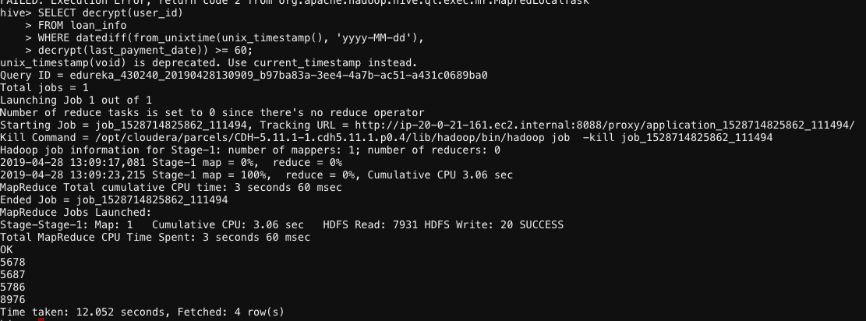

**6.2**. **Find the list of users who have a healthy credit card but outstanding loan account. Healthy credit card means no outstanding balance.**

SELECT decrypt(li.user_id)

FROM loan_info li INNER JOIN credit_card_info cci

ON decrypt(li.user_id) = decrypt(cci.user_id)

WHERE CAST(decrypt(cci.outstanding_balance) AS double) = 0.0

AND datediff(from_unixtime(unix_timestamp(), 'yyyy-MM-dd'), decrypt(li.last_payment_date)) >=

30;

**6.3. For every share and for every date, find the maximum profit one could have made on the share.**

**Bear in mind that a share purchase must be before share sell and if share prices fall throughout the day, maximum possible profit may be negative.**

SELECT share_id, share_date, max_profit(collect_list(share_price))

FROM

(

SELECT decrypt(Share_id) AS share_id,

decrypt(Gmt_timestamp) AS Gmt_timestamp,

from_unixtime(CAST(decrypt(Gmt_timestamp) AS int), 'yyyy-MM-dd') AS share_date,

CAST (decrypt(Share_price) AS double) AS share_price

FROM shares_info

DISTRIBUTE BY share_id,

from_unixtime(CAST(Gmt_timestamp AS int), 'yyyy-MM-dd')

SORT BY share_id,

CAST(Gmt_timestamp AS int)

) inne GROUP BY share_id, share_date;

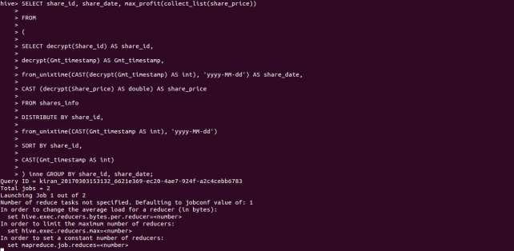

**7.Archival**

8.Survey data analysis

We have 3 survery part files. So we will copy the contents into a single file using the below linux

Commands:

cd /home/acadgild/survey_files

cat *.txt > survey_data

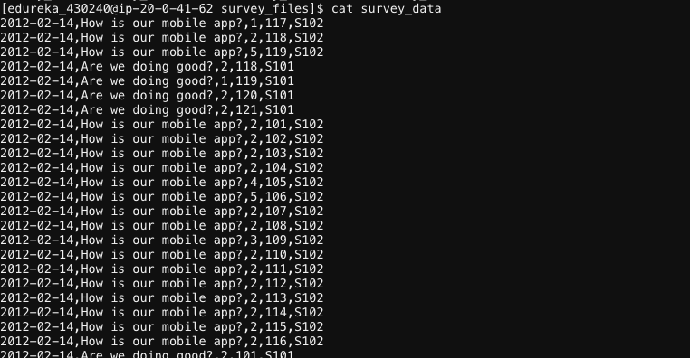

**Creating hive table to load survey_data**

CREATE TABLE survey_analysis (

survey_date string,

survey_question string,

Rating int,

user_id int,

survey_id string

)

ROW FORMAT DELIMITED

FIELDS TERMINATED BY ',';

**Loading data into survey_analysis table**

LOAD DATA LOCAL INPATH 'survey_files/survey_data' INTO TABLE

Survey_analysis;

**8.1. How many surveys got the average rating less than 3, provided at least 10 distinct users**

**gave the rating?**

SELECT survey_id, AVG(rating)

FROM

(SELECT survey_id,rating, COUNT(user_id) OVER (PARTITION BY survey_id ) AS Total_USERS

FROM survey_analysis) a

WHERE

a.Total_USERS>10

GROUP BY survey_id

HAVING AVG(rating) < 3;

**8.2. Find the details of the survey which received the minimum rating. The condition is that the**

**survey must have been rated by at least 20 users.**

SELECT survey_id, rank FROM

(

SELECT survey_id, RANK() OVER (ORDER BY avg_rating) AS rank

FROM

(

SELECT survey_id, AVG(rating) AS avg_rating FROM

(

SELECT survey_id, rating, COUNT(user_id) OVER (PARTITION BY survey_id) AS num_users

FROM bank.survey_analysis

) inner_1

WHERE num_users >= 20

GROUP BY survey_id

) inner_2

) inner_3

WHERE rank = 1;

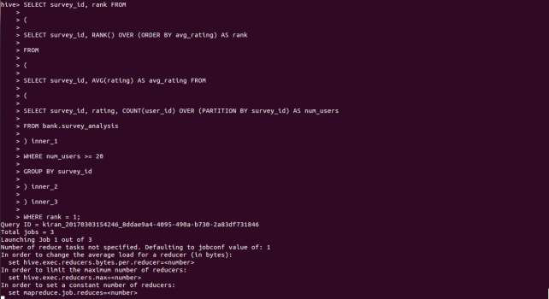

**Email data analysis**

The organisation also has lots of emails stored in small files.

The metadata about the email is present in an XML file email_metadata.xml

Read the XML file for email structure and pack all the email files in HDFS.

For reading XML data, we are using below python script to read the data from xml file.

xml.etree.ElementTree as ET

import commands

base_str = file("/home/acadgild/email_schema.xml", "r").read().replace("\t","").replace(" ","")

root = ET.fromstring(base_str)

structure_list = []

for each_col in root.findall("column"):

name = each_col.find("name").text

type = each_col.find("type").text

structure_list.append(name + " " + type)

create_table = "CREATE TABLE email_analysis (" + ",".join(structure_list) + ") ROW FORMAT

DELIMITED FIELDS TERMINATED BY ',';"

hive_file = file("/home/acadgild/hive_query.hql", "w")

hive_file.write("CREATE DATABASE IF NOT EXISTS bank;\n")

hive_file.write("USE bank;\n")

hive_file.write(create_table)

hive_file.close()

status, output = commands.getstatusoutput("hive -f " + hive_file.name)

Save this fine and run this script from command line.



You will see a file with name hive_query.hql would have been created in the terminal.



And, in hive, tables will be created under given Database.

**1. Which is the longest running email?**

SELECT id FROM

(

SELECT id, RANK() OVER (ORDER BY datediff(closed_date, opened_date) DESC) AS rank

FROM

(

SELECT id,

MIN(IF(opened="YES",reporting_date,NULL)) AS opened_date,

MIN(IF(closed="YES",reporting_date,NULL)) AS closed_date

FROM email_analysis

GROUP BY id

) inner_1

WHERE opened_date IS NOT NULL AND closed_date IS NOT NULL

) inner_2

WHERE rank = 1;

**2. Find out the list of emails which were unanswered.**

SELECT id

FROM

(

SELECT id,

MIN(IF(opened="YES",reporting_date,NULL)) AS opened_date,

MIN(IF(closed="YES",reporting_date,NULL)) AS closed_date

FROM email_analysis

GROUP BY id

) inne

WHERE opened_date IS NULL AND closed_date IS NOT NULL;